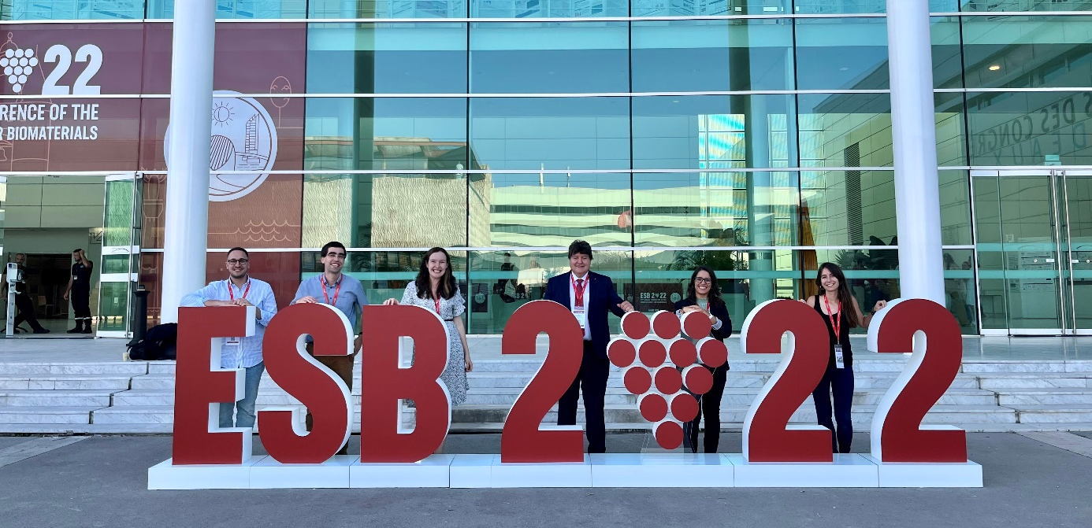

- Message from YSF's Spokesperson

Dear ESB and YSF members,
In this newsletter, it is my pleasure to give an overview of the most recent YSF events and the upcoming ones.
We are happy to have seen so many familiar faces and to have met so many new people at the ESB conference in Bordeaux. During the event, we organized multiple activities with the YSF, in collaboration with the people from BIOMAT. With this, we would like to thank the local organizers, the workshop speakers and the people from BIOMAT. We will share a few impressions of the different YSF activities (workshops, night out, general assembly).
Additionally, we still have some other announcements regarding the upcoming deadlines. We have already received multiple entrees for our logo contest and the final deadline is coming soon. We have mentioned it during the general assembly, but there will be also a picture contest. If you have a certain scientific image the entire ESB community needs to see, now is the time to show it and maybe be selected as the picture of the month on the ESB website. The yearly deadline of the YSF call for projects is also coming closer. Within our newsletter we will describe how to apply for this and who is selected this year, with their respective symposia.
Finally, there are also awards coming up, of which one (new) deadline is next month.
A lot of things to discuss! So, enjoy reading.

Best regards,
Arn Mignon
(On behalf of the YSF board)

- ESB activities organized by YSF & BIOMAT

Part I: Science Outreach and Lab to Market
Tips for successful science communication
Wonder & synergies at the service of knowledge
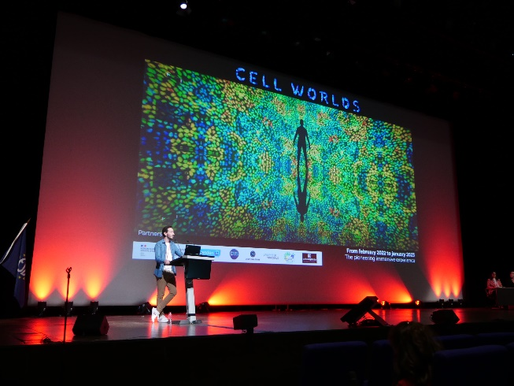
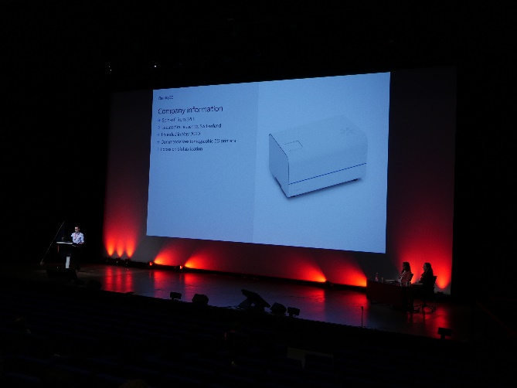
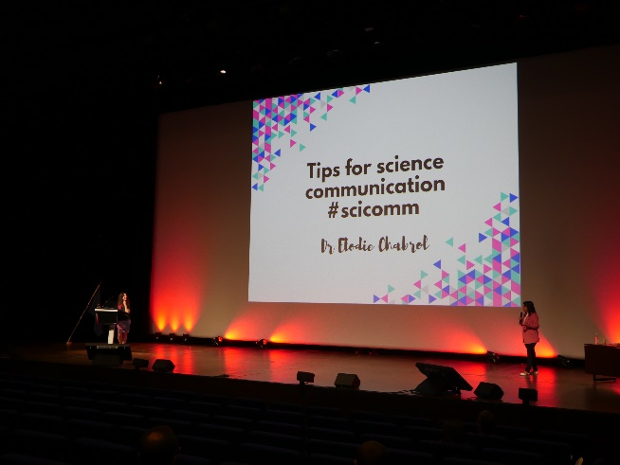
From lab to market: a giant leap

Part II: Mental Health
How to keep young researchers in a good mental shape?
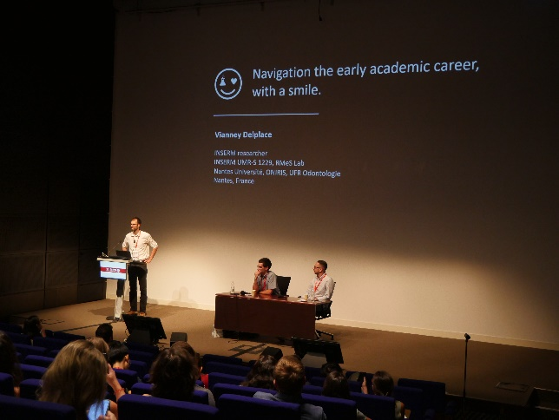
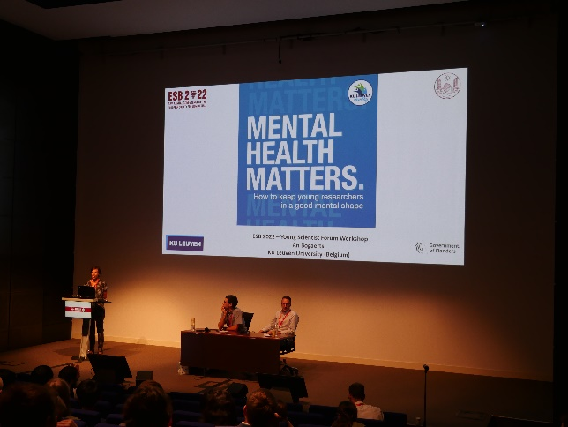
Navigating the Early Academic Career, With a Smile

ESB-YSF General Assembly
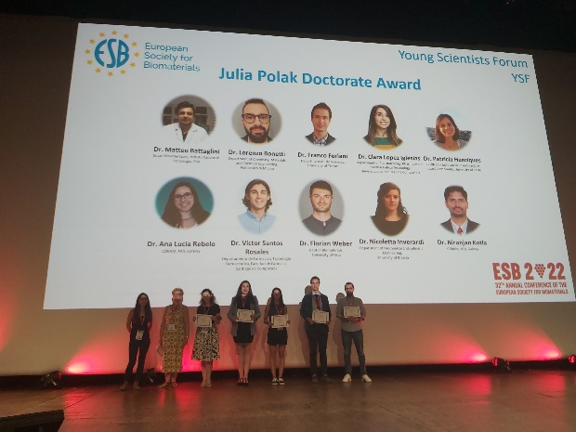

YSF Night out

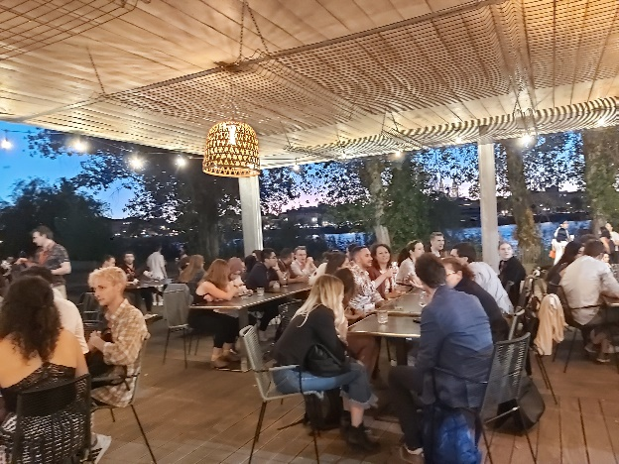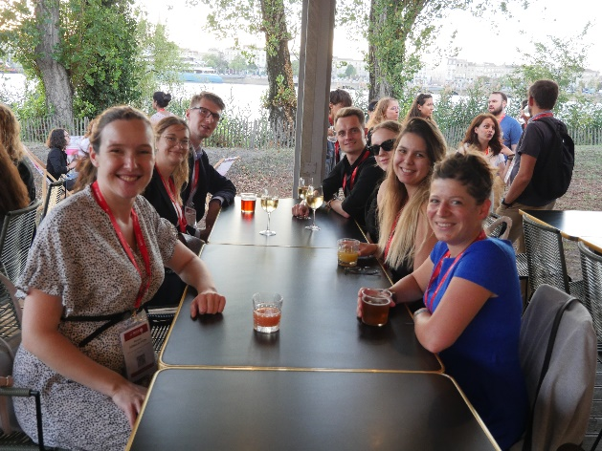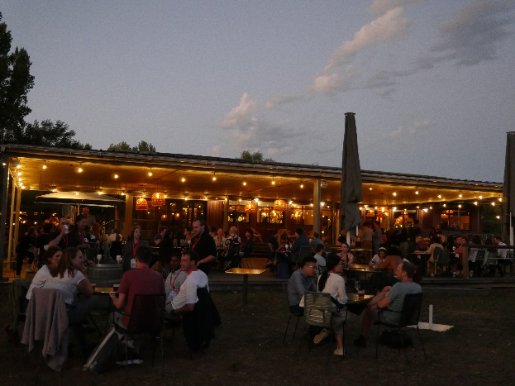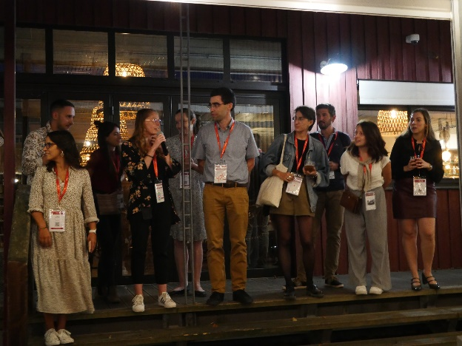

- Jobs looking for scientists / Scientists looking for jobs
Often, early career scientists are looking for a new job. The other way around, also companies or research groups might be in search of people for filling up positions. Attached to this newsletter we have added both lists filled in during the ESB conference.

- YSF Logo contest

The YSF logo design contest is still on! We are looking forward to receiving even more of innovative graphic designs that will tell our story as young European scientists passionate about biomaterials. We want as many of you to have a chance to submit your proposals as possible. Hence, we have extended the deadline to December 15th 2022.

Terms and conditions:
1. Logo entries should be submitted by email to ysf@esbiomaterials.eu .
2. The extended deadline for entries is December 15th 2022.
3. The full name ‘Young Scientist Forum of the European Society for Biomaterials’ might be hard to nicely fit into the logo design. Hence, the logo should contain either: (1) ‘Young Scientist Forum’ and ‘ESB’ acronym or (2) just both acronyms, i.e., ‘YSF’ and ‘ESB’. There are no color/format restrictions however, the logo should look good when presented together with the ESB logo (https://www.esbiomaterials.eu/). This does not mean that it has to contain the ESB logo or part of it.
4. Logo design entries will be judged based on the following criteria: 1. relevance (20%), 2. originality (20%), 3. versatility (20%), 4. simplicity (20%), and 5. aesthetics/match with the ESB logo (20%).
5. The prize is €150 and a certificate. The money will be transferred to the account provided by the winner.
6. Designs must be submitted in *.PNG or *.TIFF format with high resolution. Color and black & white versions should be included.
7. Logo designs must be original and cannot violate any copyrights. Submitting individuals will be held accountable for any issues that may involve intellectual property violations.
8. IP: all submitted designs will become the property of the Young Scientist Forum of the European Society for Biomaterials. YSF-ESB reserves the right to make minor necessary adjustments to the winning design to meet any technical requirements that may occur.
9. The organizers (YSF-ESB) reserve the right to terminate the Contest without selecting a winner. In such a case, the Contest might be re-opened for additional submissions.

- YSF/ESB Picture contest

Can your research be captured in an appealing scientific photo? You can now participate in our Scientific Image Competition! Each month, one will be selected to be represented on the ESB website for making your research more visible to the whole community.
Rules:
- applicants should be students, PhD candidates, postdocs, or technicians.
- only one image per participant is allowed
- the subject matter of the competition images is very flexible, but it should reflect research in Biomaterials and/or Tissue Engineering
- editing is allowed but the image should depict a real “object”
- the entry must be sent by email as high resolution .tiff, .jpeg or.png file (ideally minimum resolution of 2 megapixel/200 dpi, if the instrument allows it)
- the entry must be sent together with the filled application form (Image Competition form.docx) to ysf@esbiomaterials.eu with as subject: Picture Contest (if needed, you can use a file transfer service to upload the photo e.g., WETransfer / Surf Filesender)
*Each month the awarded image will be posted on the ESB website.
See also our YSF website at the events page where the contest is also announced.

- YSF Call for projects

YSF-ESB Call for projects is an annual initiative of the YSF board, sponsoring the organization of events/workshops for a total amount up to 1,200 Euros. The final aim of the call is to promote the training of young scientists and to stimulate dissemination in the field of biomaterials in Europe.
The call is now open for events/workshops to be organized in 2023. The YSF call for projects gives you a wonderful opportunity to gain financial support for all those activities. Plan ahead your national or European 2023 activity focused on training young scientists and science dissemination and do not hesitate to apply. All young YSF-ESB members (under 40 years old) are eligible, provided they have contacted their National Chapter (NC) representative or the NC Liaison Officer (Dr. Patrycja Domalik-Pyzik: pdomalik@agh.edu.pl) before sending the application.

Please note that the deadline for the submission of the project on this call is the 31st January 2023. If you need more information, please contact us at: ysf@esbiomaterials.eu.

​
It is also our pleasure to recommend the two events sponsored this year:

- Symposium for Early Career Scientists “Regulatory Affairs in Biomaterials and Biomedical Devices” organized by Dr. Paula Soares and Dr. David Barata, to be held 11 November 2022, 14 pm (GMT). This symposium will bring closer aspects of regulatory affairs that young scientists in biomaterials and biomedical sciences should keep in mind in due time. To take part simply register here: https://t.co/0MpIXl22Fd
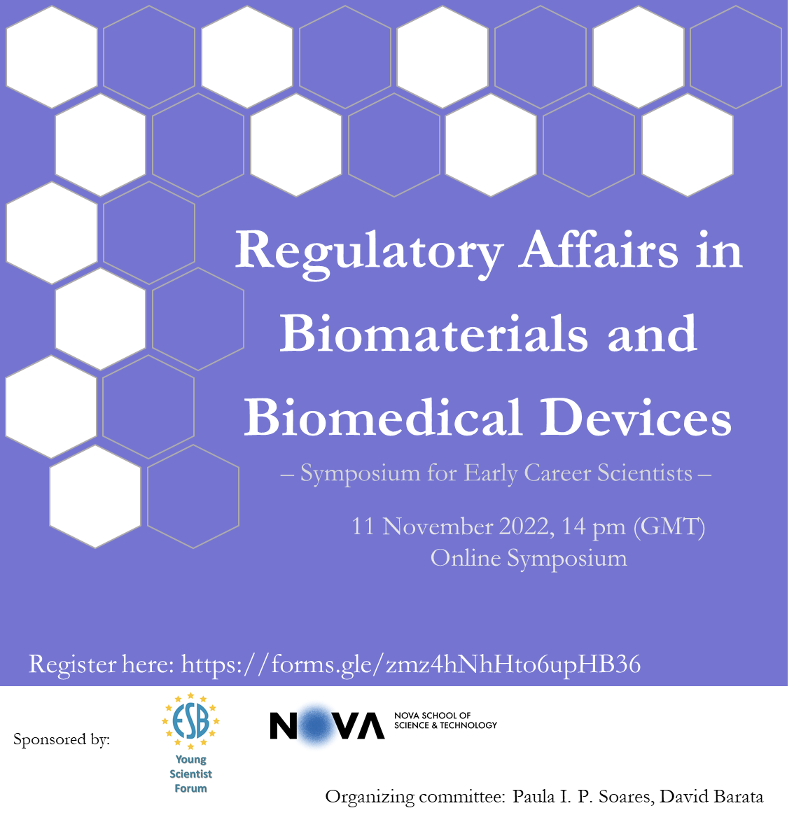

- The Annual Meeting for the Belgian Society for Tissue Engineering
(2 - 3/12/2022) that Dr. Bert Van den Bogerd helps to organize. This conference is dedicated to the Belgian community of young biomaterials scientists. It covers the whole domain of tissue engineering and aims to bring together a mix of different scientific backgrounds. ​ https://bste.be/event/annual-meeting-bste-2022/about/

- Educational awards

The deadline submission for Racquel LeGeros is getting close (November 30th, 2022)! We look forward to outstanding candidates willing to travel abroad to learn new techniques, increase their scientific network, and experience a new culture.

With this fellowship, ESB offers the opportunity to two graduate students to pursue their research in International or European academic laboratories or companies dedicated to biomaterials and regenerative medicine, aiming to increase their knowledge in a specific topic and /or technology.

Remember that the candidates should provide to Prof. Karine Anselme (karine.anselme@uha.fr) and to the ESB secretary (secretary@esbiomaterials.eu): (1) a Curriculum Vitae with the ESB membership certificate, (2) a page that describes the objectives of the project and the added value of the mobility, (3) a supervisor letter from the home laboratory (member of ESB), stating that he/she is member of the ESB at the time of the application, and supporting the candidate’s project/mobility, (4) a letter from the host laboratory (member of ESB), stating that he/she is member of the ESB at the time of the application, and supporting the candidate’s project/mobility.

